**Reflection on Website.**

**Technical.**

On the technical side of the creation of this website, I used the tools I had learned throughput the quarter to create a website which (I hope) meets the requirements of the brief.

Each page started with a small navigation bar at the top followed by a larger one. The smaller bar contains the title in one corner and the links to the various pages on the other.

Upon visiting each page, the user is given the following.

* An indicator of what page they’re on.
* A description of what will be found on the page.
* Links to the works mentioned above.
* The ability to switch between the different pages.

I think this covered the requirement for ‘multiple pages with appropriate hyperlinking between them. This linking can also be found within the individual works, making it easier to go back and read something else, if the user so desires.

As for ‘the appropriate use of semantic markup, headers and microformats’ I think I did an acceptable job of this.

In an attempt to better manage my code and the various pages, I decided to place each page and its respective contents into a folder. So, a folder for the portfolio would include; the portfolio webpage, the portfolio pieces and the CSS styling sheets for these pages. I also decided to use different style sheets for each page even though they turned out to be largely the same. I did this because I wanted to be able to finetune aspects of each page individually is I saw fit. Ultimately, I did not really need to do this as the only change was the backgrounds but I’m glad I was prepared for the eventuality… even if it didn’t happen.

Most of the actual code as you’ll notice is just copy-&-paste. This is because each page had to function in a very similar way. So in essence, once I had finetuned one page, I could apply the same logic across the board and just tweak it if necessary.

In the start I struggled somewhat with the CSS. Some things refused to fit in the way I wanted them, and I spent a lot of time tweaking and trying to get it right. Once I did I was precariously perched on a cliff which lead to a rabbit hole of CSS but thankfully I was able to pull myself away.

In conclusion the evolution of my site over the quarter was marked by a few hurdles (most of them supplied by Eskom), most of which I was able to overcome.

**Creative.**

The creative choices I made around the webpage were inspired mostly by the content of my portfolio, writing. As such I went with a library theme and chose appropriate colors and background pictures, in keeping with this theme.

Each page contained.

* The title, which was big & bold, and placed in the left-hand corner as is often the convention.
* The links to the various pages were placed on the right, spaced out and also emboldened making it easy to read.
* The second navigation bar which contained a title, confirming the page the user is on and a small, concise description of what to expect from the page.

I think my site is quite user friendly and makes use of UI and UX principle to afford the user ease of access across the site.

As for the design decisions I think I achieved a palatable aesthetic which helped to create a theme about what the user could expect. The different backgrounds will, I hope, help to further differentiate the pages, and give more hints of what to expect.

Here are some of my wireframes and plannings for this assignment.

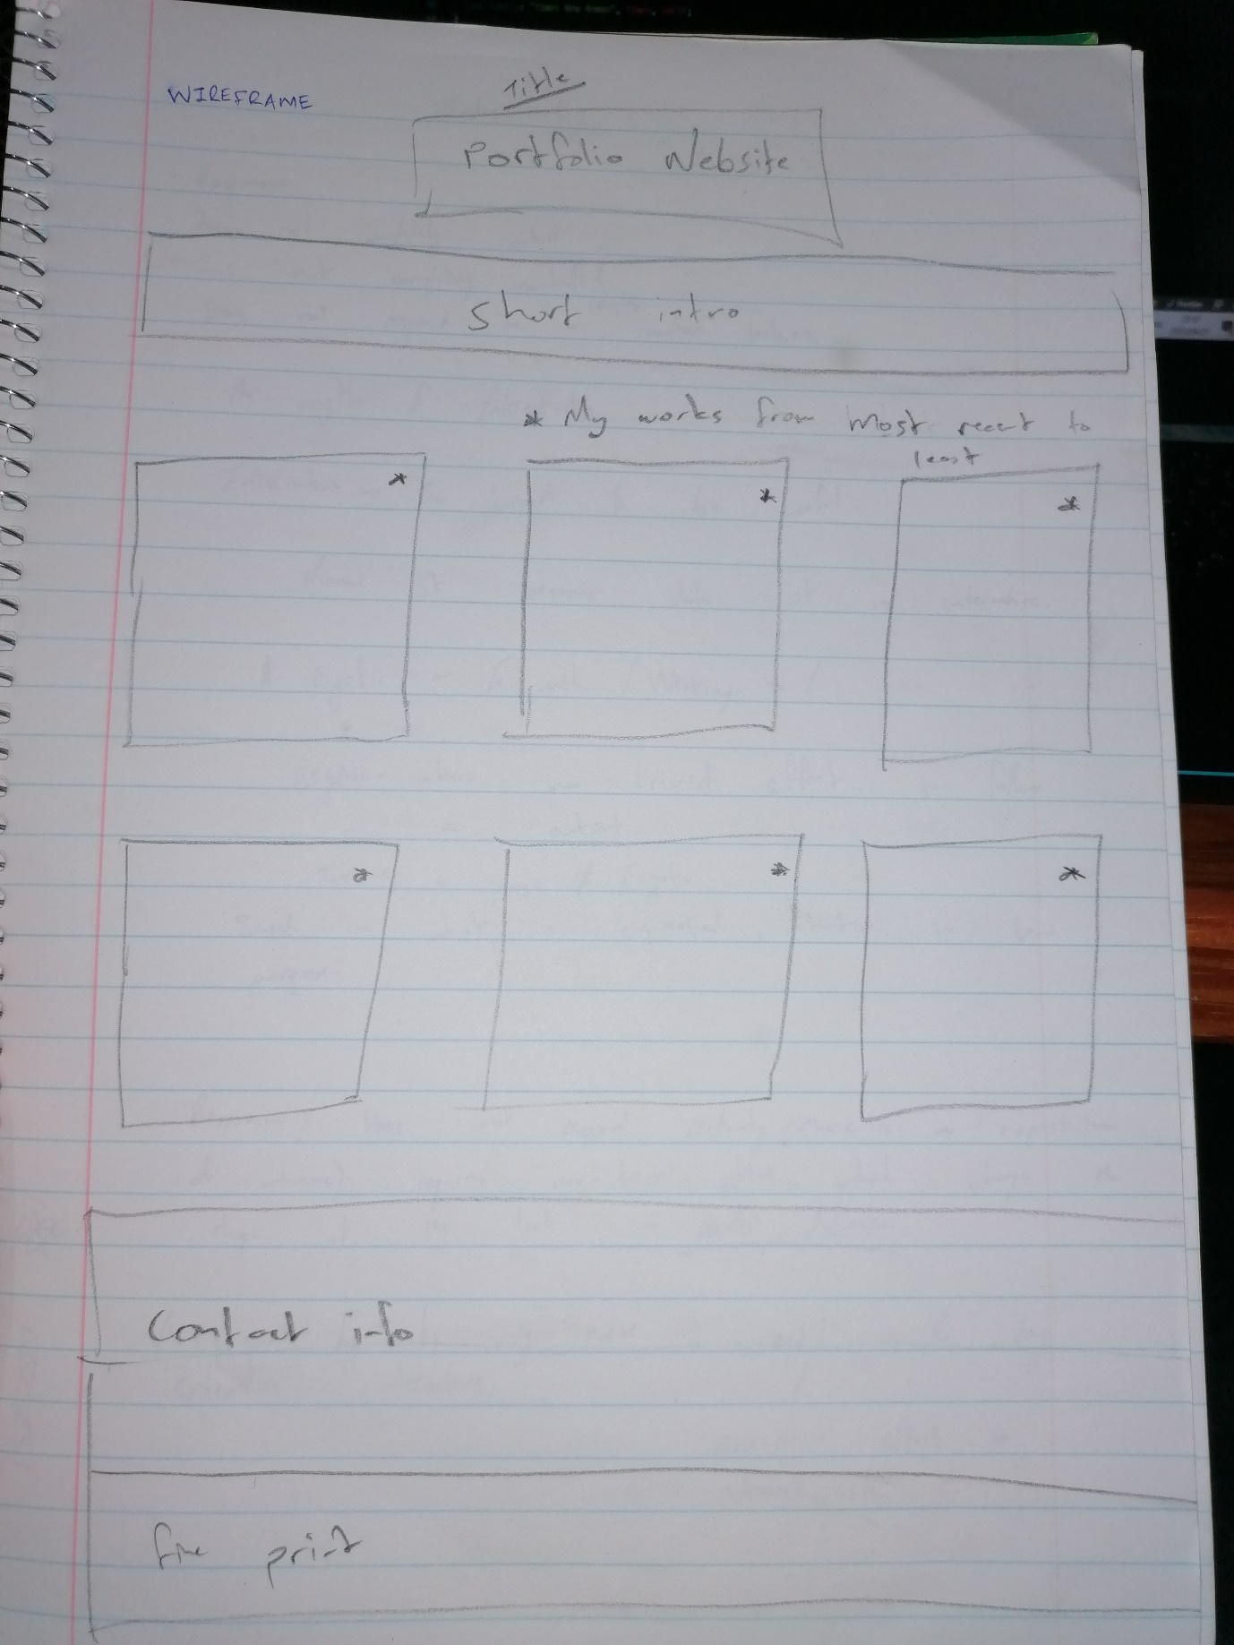

Wireframe 1.

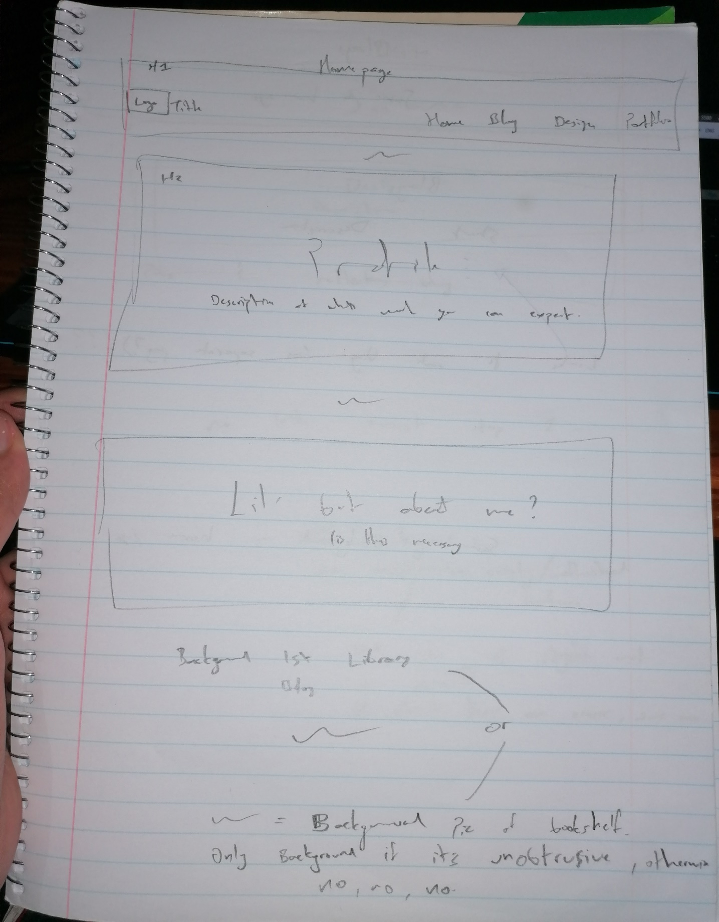

Wireframe 2.

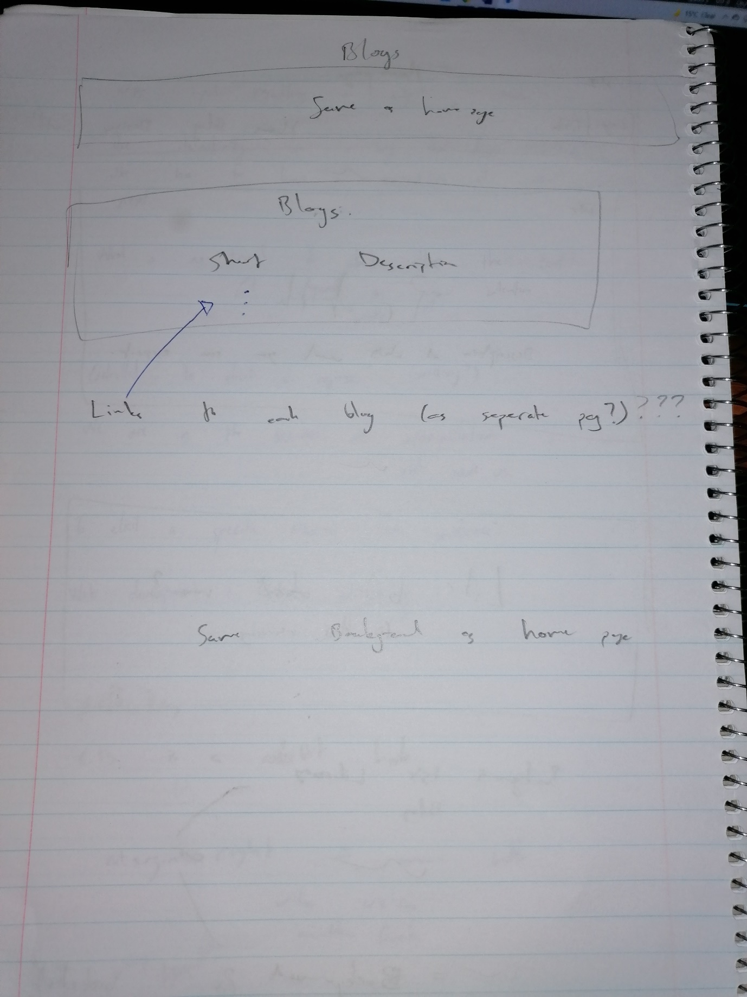

Wireframe 3.

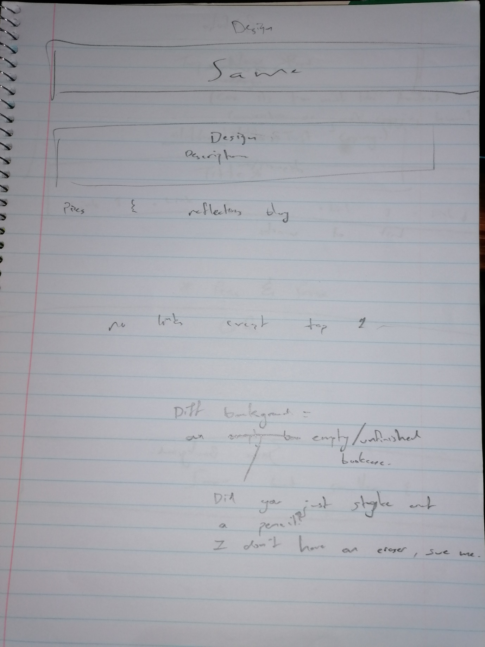

Wireframe 4.

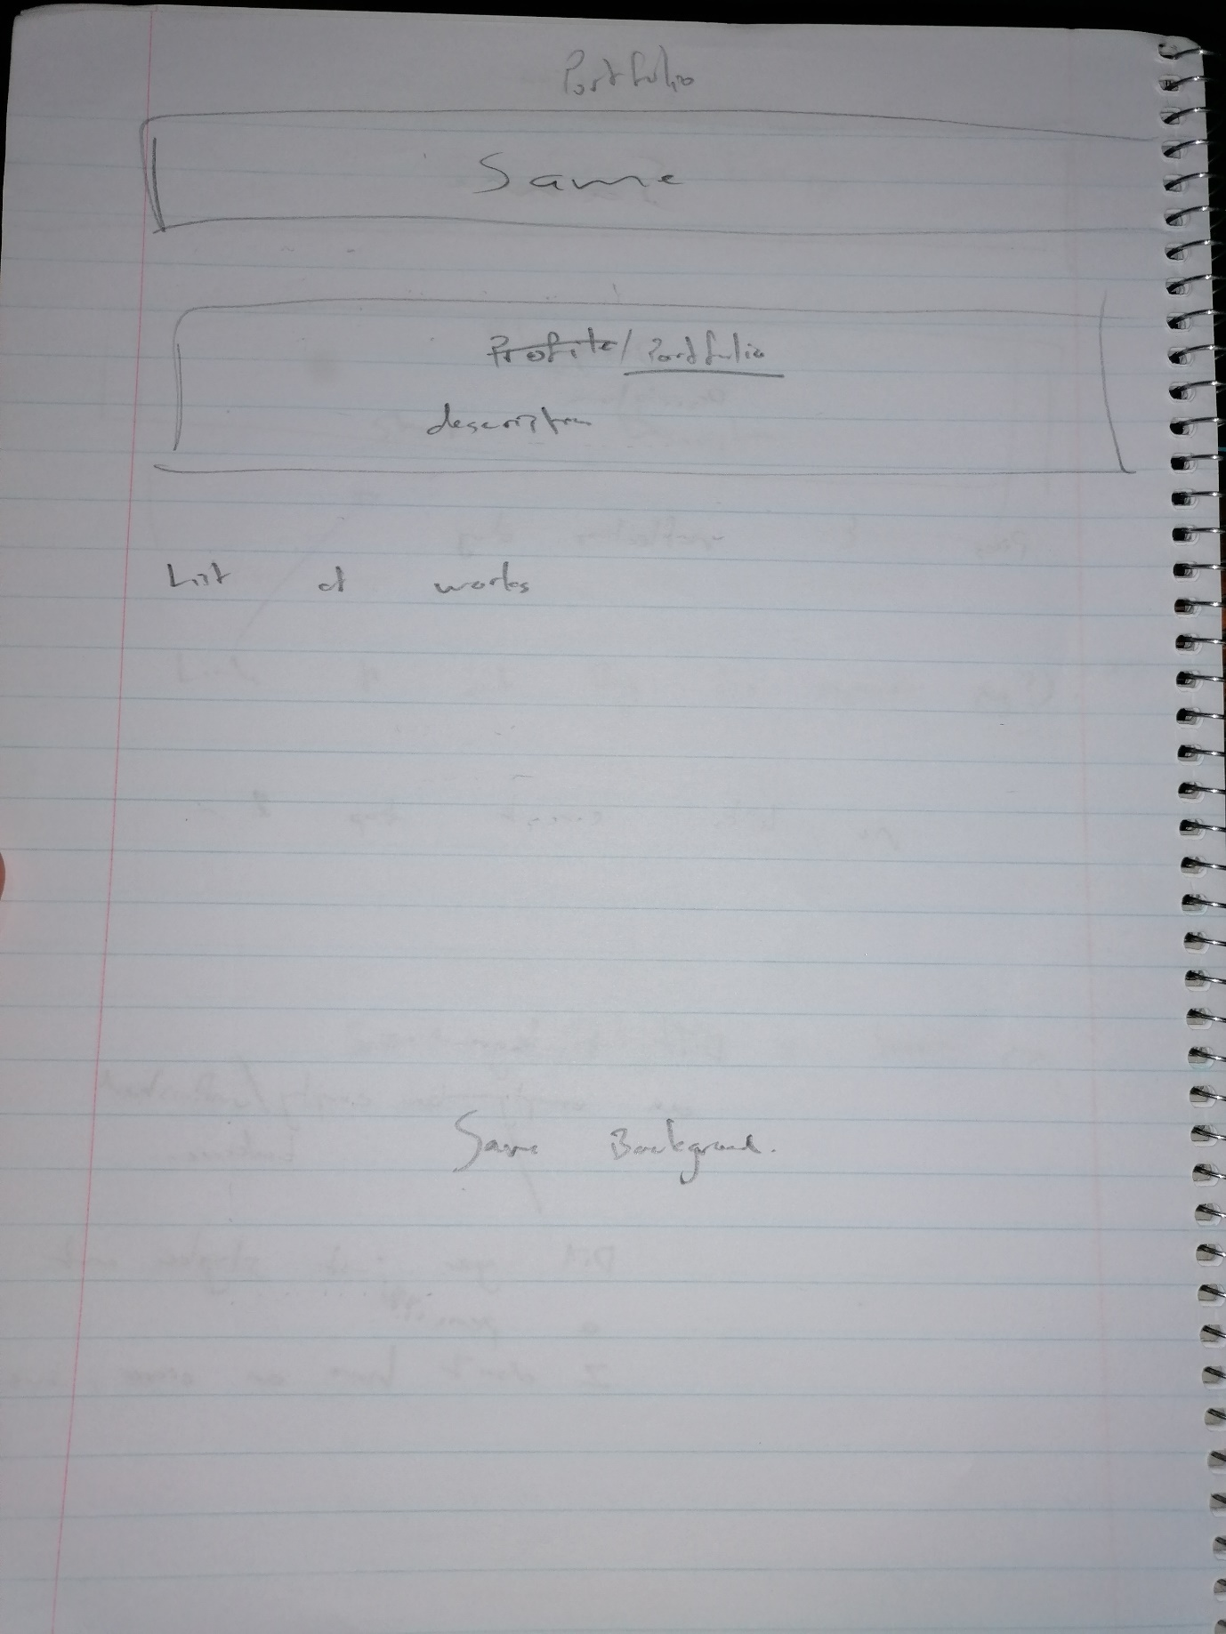

Wireframe 5.

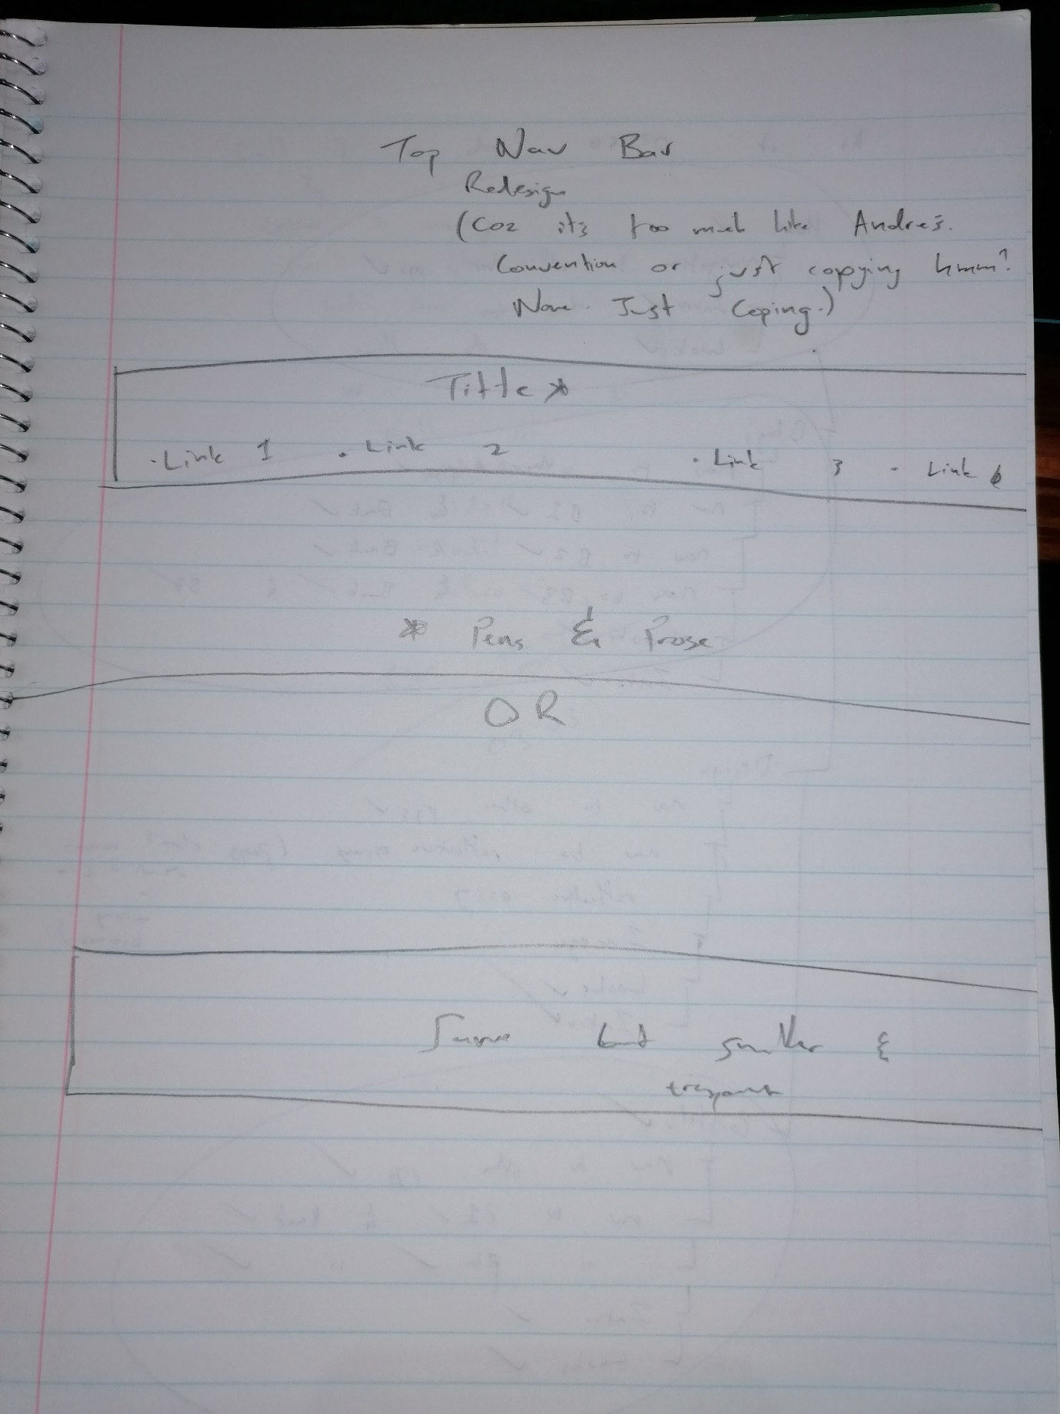

Wireframe 6.

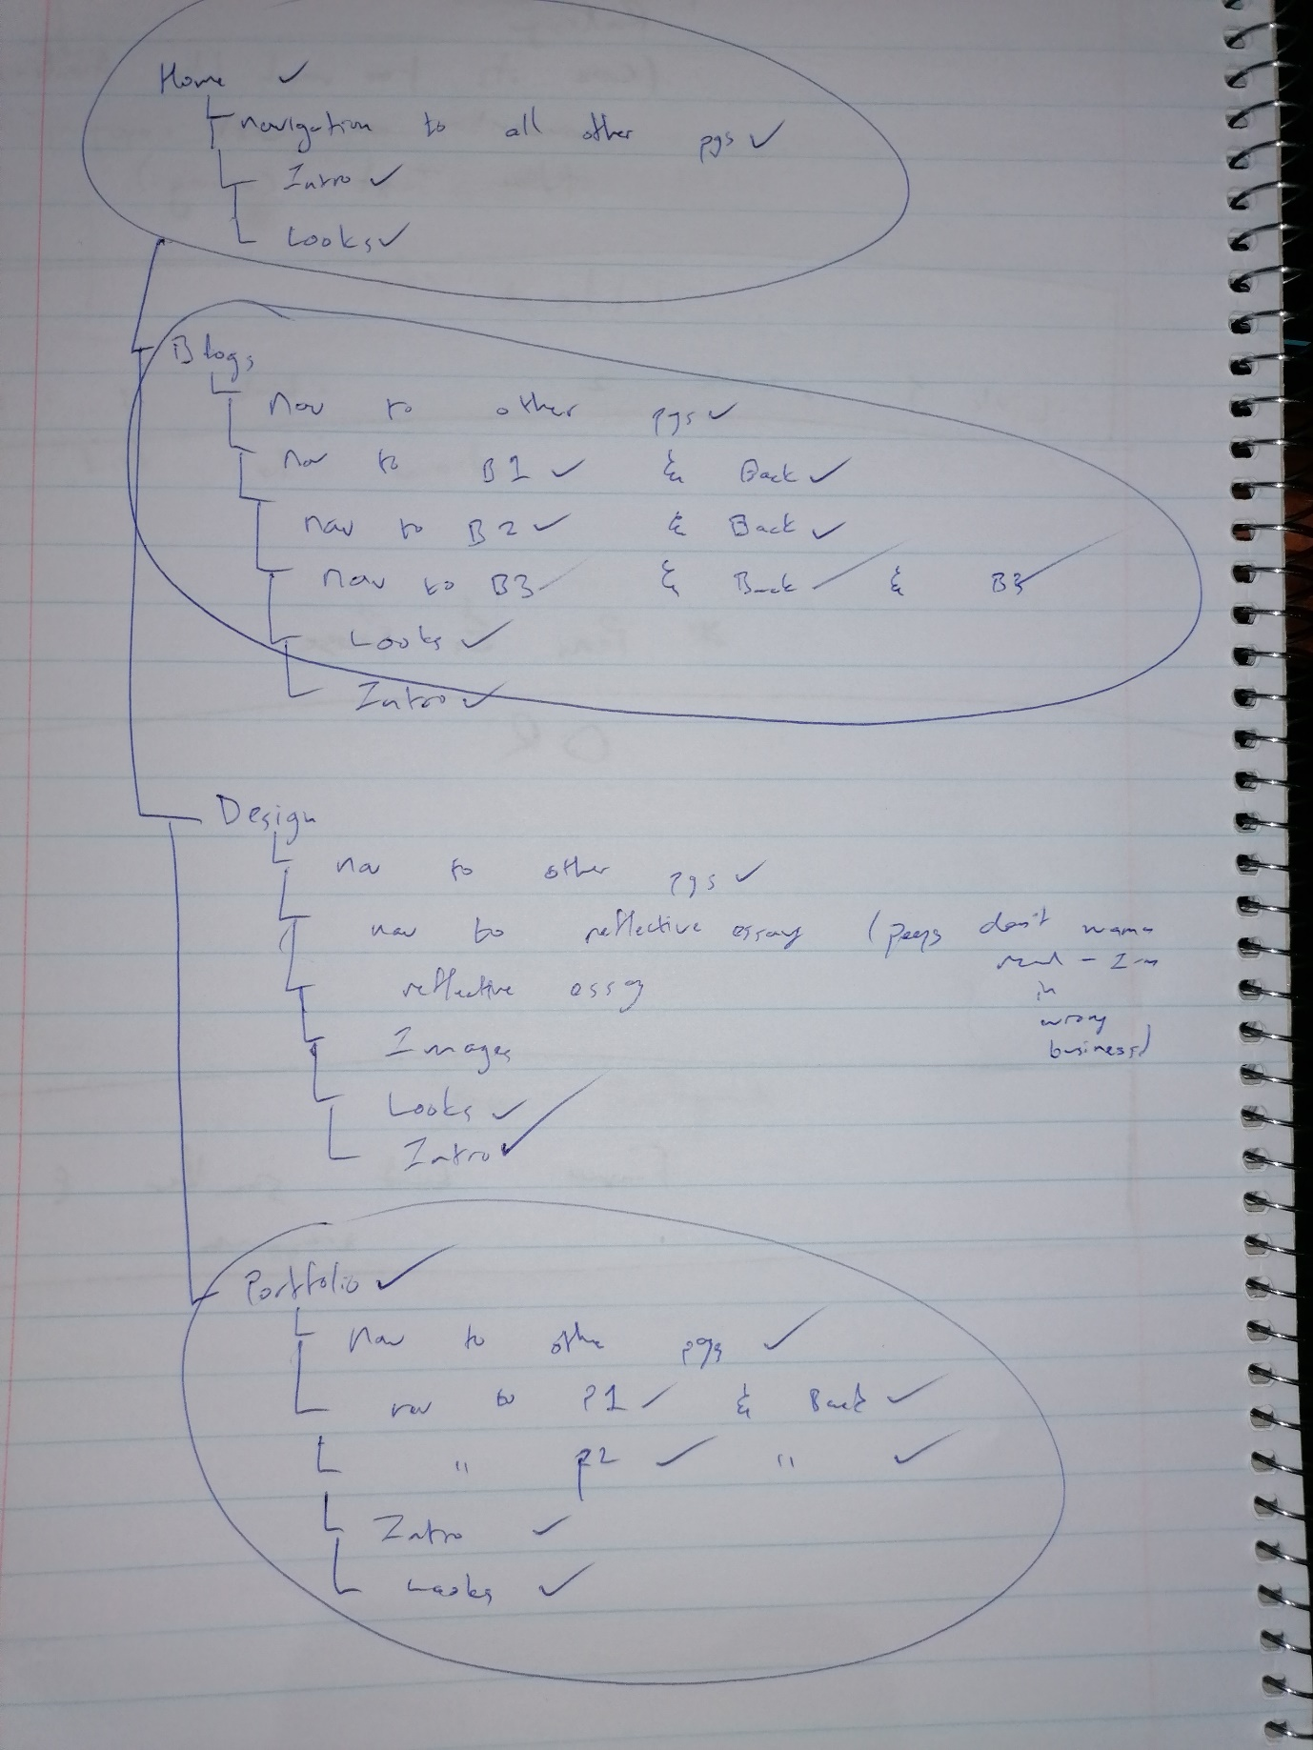

Planning.